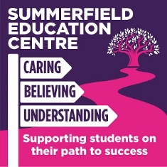

SUMMERFIELD EDUCATION CENTRE – COVID 19 CATCH UP FROM SUMMER CURRICULUM FOR SEPTEMBER 2020
KEY FLUENCY LEARNING YEAR GROUP BEFORE MOVING ONTO
SUBJECT AREA: Media

* | R081 Pre-production R082 Digital Graphics | Completed
1. | Investigate Purpose and uses of digital Graphics | KS4 *** KS3
2. | Investigate different File Formats | KS4 *** KS3 ***
3. | Research: Target Audience | KS4 *** KS3 ***
4. | Primary and Secondary Research | KS4 KS3 ***
5. | Planning: Understand the purpose and uses of Mind maps, Mood Boards, Storyboards, Scripts and Visualisations, camera shots & angles | KS4 KS3 ***
6. | What is a Recce? Health & Safety : Risk Assessments | KS4 KS3 ***
7. | What are client requirements | KS4 *** KS3
8. | What is a work Schedule (Gantt file)? | KS4 *** KS3
9. | Difference between hardware and software | KS4 *** KS3 ***
10. | Legal Issues and copyright | KS4 KS3
11 | Software Photoshop tutorials | KS4 *** KS3 ***
 | Curriculum order has changed dude to period of lockdown. When learners are in the building I have had to teach Photoshop in order for them to be able to complete R082. | KS4 *** KS3 ***

