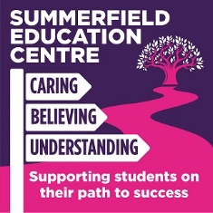

SUMMERFIELD EDUCATION CENTRE – COVID 19 CATCH UP FROM SUMMER CURRICULUM FOR SEPTEMBER 2020
SUBJECT AREA: Food Technology
KEY FLUENCY LEARNING YEAR GROUP Key Stage 3
BEFORE MOVING ONTO: Hospitality and Catering Level 1/2 (Year10)

* | Skills based tasks | Completed
To understand the types of flour available and the different uses in cooking.
- Plain flour – Pastry and biscuits.
- Self-raising flour- Cakes, sponges.
- Strong flour – Breads and doughs.
1. | Making a basic batter mix – Pancakes | September 20
2. | Creaming method – Small batch of cakes | September 20
3. | Creaming and melting method - Cookies | September 20
4. | Pastry – Jam tarts | October 20
5. | Sweet short crust pastry | October 20
6. | Rubbing in method - Crumble | November 20
* | Nutrients and Food Labelling
Revisit learning from Autumn Term to embed previous knowledge and understanding.
To understand the principles of a healthy balanced diet and the benefits.
1 | Nutrients and their benefits | October 20
2 | Sugars and Salts in food | November 20
3 | Vitamins and minerals - why are they important. | November 20
4 | Food labelling- Traffic light system | November 20
5. | 5 A day - Encouraging young children to eat fruit and vegetables | October 20
* | Food Safety
To understand the principles of food/personal hygiene.
Safe storage and handling of food. To understand the main causes and symptoms of foodborne illness.
1. | Food additives/ allergies
2. | Food choices / dietary needs.
4. | Boiling – Eggs (Salmonella , Cross contamination) | November 20

