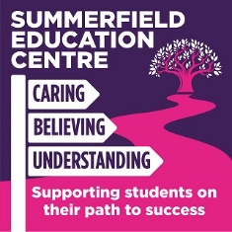

SUMMERFIELD EDUCATION CENTRE – COVID 19 CATCH UP FROM SUMMER CURRICULUM FOR SEPTEMBER 2020
KEY FLUENCY LEARNING YEAR GROUP BEFORE MOVING ONTO
SUBJECT AREA: Music Technology

* | Be The Audience (Bronze Arts Award - Part B) KS4 | Completed
1. | Experience an art form as an audience member
2. | Critique an art form using specialist terminology
 | As shown in my curriculum plan the students should have experienced an art form as an audience member however due to social distancing restrictions this has been postponed, students have moved onto Part D and will revisit this during Catch Up Time (Summer Term 2).
* | Create (Arts Award Explore - Part C) KS3 | Completed
1. | Plan an original composition
2. | Complete an original composition
3. | Evaluate an original composition
 | As shown on my curriculum plan the learners should have completed their 3rd and 4th research projects after this module and then started Present - Part D. They will now be completing Part C first as this module is not possible to complete via remote learning.
Due to students starting at various stages throughout the year some newer students are not following the subject year plan and are one term behind.
All students in KS3 and KS4 have been moved onto modules that cannot be delivered remotely just in case another school closure takes place.

