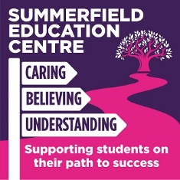

SUMMERFIELD EDUCATION CENTRE – COVID 19 CATCH UP FROM SUMMER CURRICULUM FOR SEPTEMBER 2020
KEY FLUENCY LEARNING YEAR GROUP BEFORE MOVING ONTO:
SUBJECT AREA: E.G. ENGLISH – English Language Paper 1 Autumn Term

* | English Language Paper 1 for KS4  Creative Writing for KS3 | Completed
1. | Question 3 – structure – how has the writer structured the text to interest you as the reader? Yr 10 CH/JT/TH all behind due to behaviour and attendance. KS4
2. | Q2 and Q3 of Lang Paper 1 JLK Yr 10 behind due to attendance. KS4
3. | Question 2 and 3 TCP behind in practice due to being a late starter – intervention needed. KS4
4. | Q3 and Q4 – GD behind due to attendance. KS4
5. | KS4 – Yr 11 continue to practice Q1-4 for Paper 1.
6. | KS3 – creative writing; falling behind due to attendance and behaviour issues.  Most done some CW for the Fairy Tale modules.  Writing descriptively in detail.

