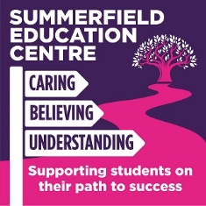

Summerfield Education Centre – Covid 19 catch up from summer curriculum for September 2020

Subject area: PE
Key fluency learning year group: Years 7-9 (KS3)
Before moving onto: Hockey (Autumn Term)
* | Cricket
1. | Ball Familiarization e.g. individual, partner & team work and fun games involving the ball
2. | Throwing and Catching e.g. underarm, overarm, throwing for distance & accuracy, games involving throwing & catching, work on accuracy and distance
3. | Batting & Bowling e.g. grip, stance, swing, timing of the ball, introduce rounders balls, pendulum action, speed
4. | Fielding and deep fielding e.g. stopping the ball, collecting, retrieving the ball, decision making, accuracy, power of the ball
5. | Mini-Games e.g. sportsmanship, team work, match competition, mass participation, enjoyment
* | Athletics
1. | Throwing e.g. throwing for distance, throwing with control,
2. | Sprint speed and relay take over e.g. running, sprinting, starting, racing
3. | Hurdles e.g. running, sprinting, take off, flight, landing
4. | Long jump e.g. jumping to your maximum, jumping for height, jumping for distance
5. | High jump e.g. jumping to your maximum, jumping for height, jumping for distance

