Summerfield Education Centre Lockdown Art homework – Year 10
Previously
we’ve been exploring Graffiti Art/letters and developed 3D graffiti letters from cardboard/paper mache
Work to be completed at home
- Create a collage from recycled materials around your home. Please make sure you get permission to use the bits and pieces you find first. Find a piece of card or thick paper or even a piece of plywood to make the collage on. This collage could be made using anything – fabric, cardboard, old newspapers, objects. Use glue to stick them down.
The collage could be abstract or figurative. It could depict natural forms like trees, leaves or the ocean.

It could be made as objects for display on your walls like the 3D letters that have been made at school.

Here are some ideas for you:

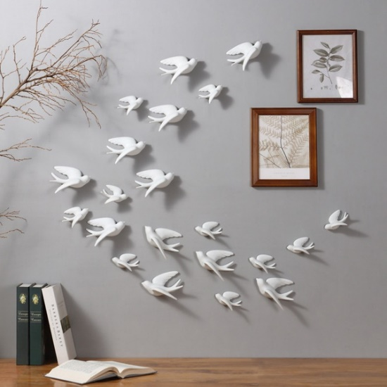 These doves could be made from any recycled materials like cardboard/paper mache/metal.

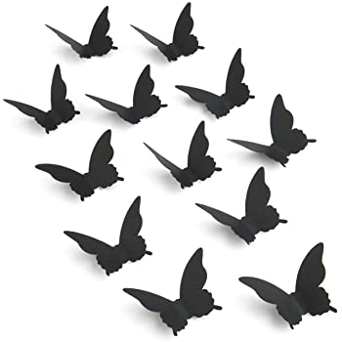

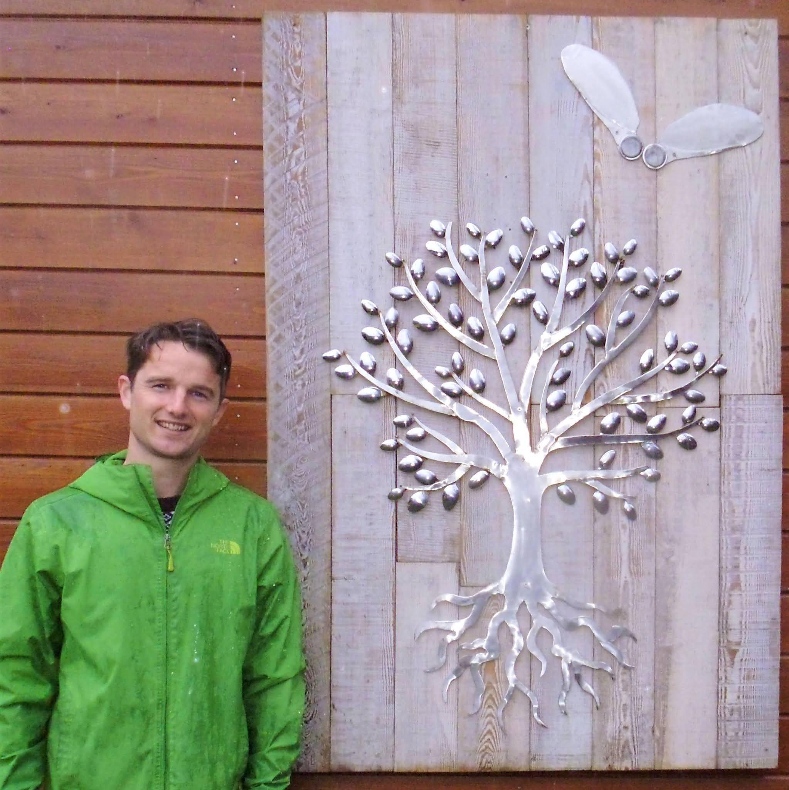

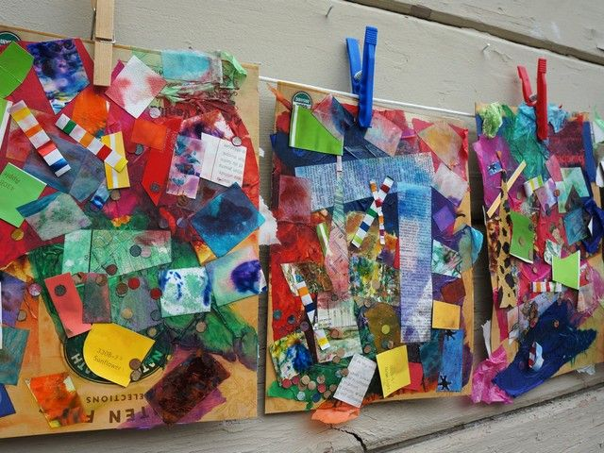

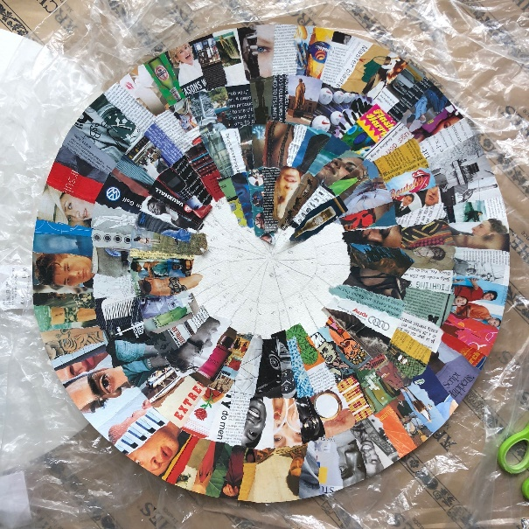

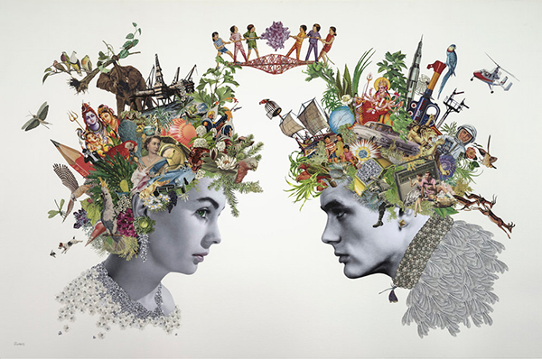

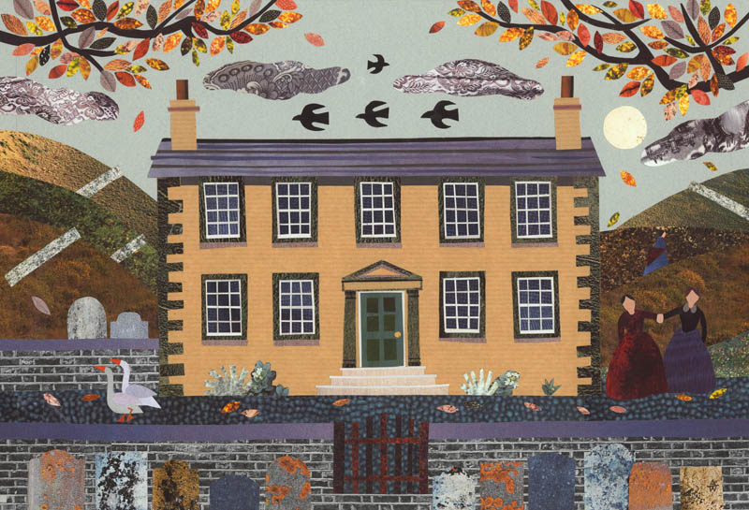

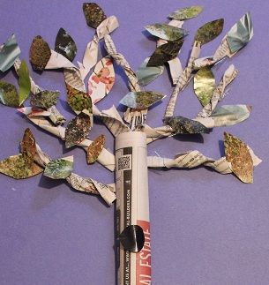

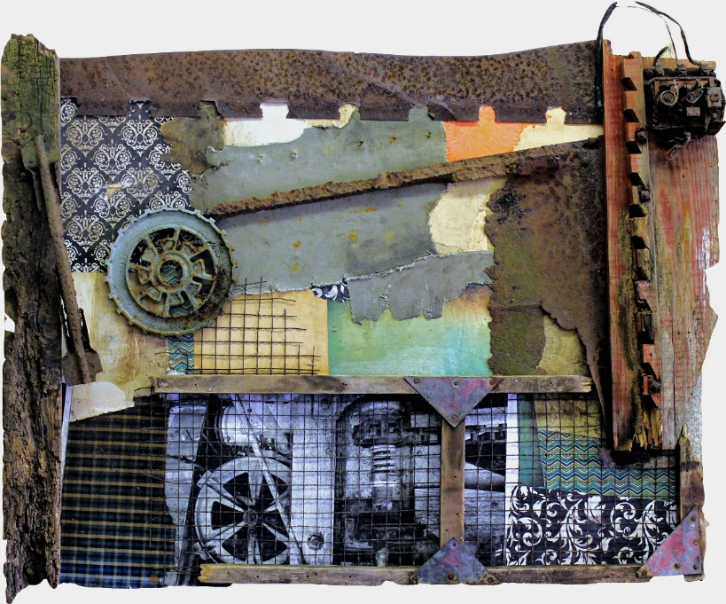

- Look up each of the words below and write down their meanings.

Abstract

Figurative

Depict

Lastly, for each of the words above, write a sentence using the words.

1.

2.

3.

