Labelling Joints.
What to do – can you label the following diagrams?
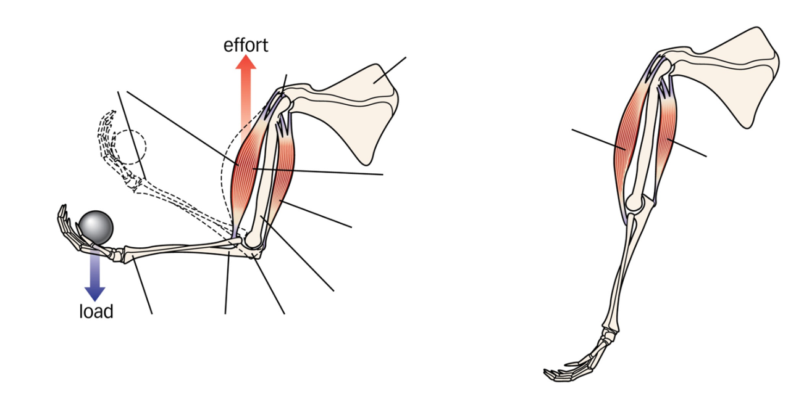
Use the following labels
Radius, ulna, scapula, tendon, triceps relaxed, biceps relaxed, biceps contracts, triceps contracts, humerus
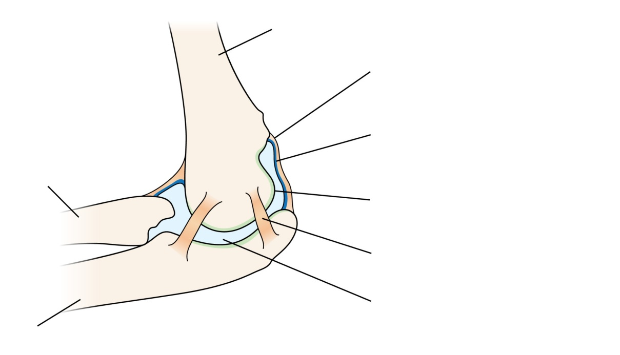
Use the following labels
Humerus, radius, ulna, synovial membrane, cartilage, ligament, synovial fluid

