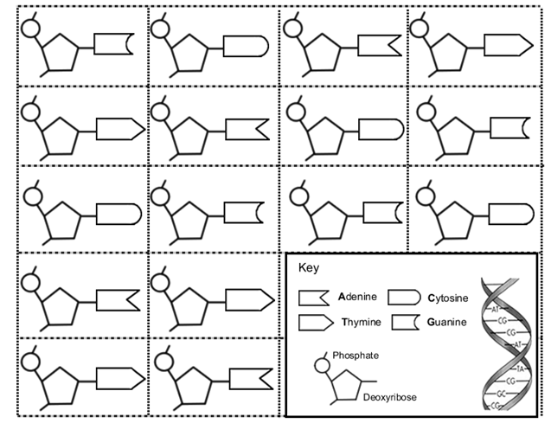

- Cut out each of the nucleotides and arrange them on the grid. Remember the Base-Pair Rule. (You will have one set left over). Separate paper may also be used.
- To match the pairs, one of the nucleotides must be arranged upside down. The sides of the DNA double helix are arranged in an anti-parallel fashion. Think of them like lanes on a highway going different directions.
- Colour each of the nucleotides:
Thymine = orange, Adenine = green, Guanine = purple,
Cytosine = yellow, Deoxyribose sugar = blue, Phosphate = pink

